Boot Loader : The source which is used for initlization of the hardware, kernel and loading OS from the ROM to execute and run the system performance.
Intro:
U-Boot is the most popular bootloader in the linux based embedded devices.it is released as open source under the GNU GPLv2 license.It supports a wide nrange of microprocessors like MIPS, ARM,PPC,Blackfin,AVR32 and X86.It even supports FPGA base nios platforms.if your hardware device is based out any of these processors and if you are looking for a bootloader the best bet is to try u-boot first.It also support different methods of booting which is pretty much needed on fallback situations.The list of filesystems supports by u-boot is more. It has support to boot from USB, NAND, NOR,SD Card.It also had the support to load the linux kernel from the network from the TFTP .
Last but not least it also has the command line interface which give you very easy access to it and try many things before finalizing your design.You can configure U-BOOT for various boot methods like MMC, USB,NFC or NAND based and it allows you to test physical RAM of any issuses.

Stages in Bootloader :
For Starters U-Boot is First stage and Second stage bootloaders.When U-Boot is compiled we get two images first stage (MLO) and second stage (u-boot.img) images. It is loaded from the system’s ROM code from a supported boot device. The ROM code checks for the various boot device that is available.And starts execution of the device which is capable of booting. This can be controlled through jumpers,though some resistor based methods are also exists.since each platform is different.

Stage 1 Bootloader is sometime called Small SPL(Secondary Program Loader).SPL would do inital hardware configuration and loads rest of U-boot.Regard less of whether the SPL is used or not U-Boot will do both the First-stage and secondary-stage booting.

In First stage U-boot initlizates memory controller and SDRAM.This is needed as rest of the execution of the code depends on this. Depending upon the list of the devices it supported by the platform it initlizes the rest. For example if your is supported by the USB to boot and their is no network connectivity then U-Boot will do exactly the same.
If you want to use linux kernel,then setting up of memory controller is only mandatory thing expected by linux kernel. If memory controller is not initilzed properly then linux kernel wont be able to boot.

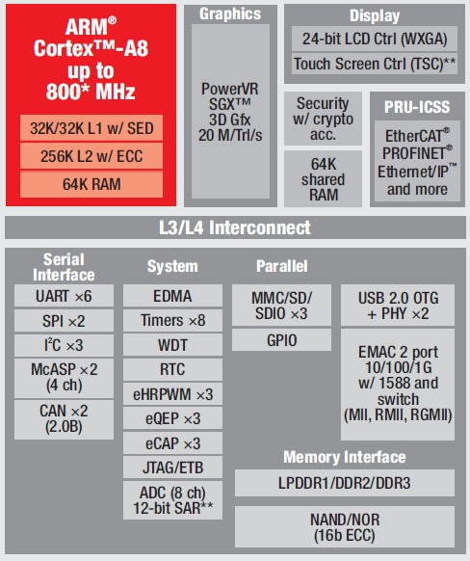

Block Diagram of Target
U-Boot Phases
U-Boot boots through the following phases:
TPL
Very early init, as tiny as possible. This loads SPL (or VPL if enabled).
VPL
Optional verification step, which can select one of several SPL binaries, if A/B verified boot is enabled. Implementation of the VPL logic is work-in-progress. For now it just boots into SPL.
SPL
Secondary program loader. Sets up SDRAM and loads U-Boot proper. It may also load other firmware components.
U-Boot
U-Boot is both a first-stage and second-stage bootloader. It is loaded by the system's ROM (e.g. onchip ROM of the ARM CPU) from a supported boot device, such as an SD card, SATA drive, NOR flash or NAND flash. If there are size constraints, U-Boot may be split into two stages: the platform would load a small SPL (Secondary Program Loader), which is a stripped-down version of U-Boot, and the SPL would do some initial hardware configuration (e.g.DRAM initialization using CPU cache as RAM) and load the larger, fully featured version of U-Boot.Regardless of whether the SPL is used, U-Boot performs both first-stage (e.g., configuring memory controllers and SDRAM) and second-stage booting (performing multiple steps to load a modern operating system from a variety of devices that must be configured, presenting a menu for users to interact with and control the boot process, etc.).
U-Boot implements a subset of the UEFI specification as defined in the Embedded Base Boot Requirements (EBBR) specification.UEFI binaries like GRUB or the Linux kernel can be booted via the boot manager or from the command-line interface.
U-Boot runs a command line interface on a console or a serial port. Using the CLI, users can load and boot a kernel, possibly changing parameters from the default. There are also commands to read device information, read and write flash memory, download files (kernels, boot images, etc.) from the serial port or network, manipulate device, and work with environment variables (which can be written to persistent storage, and are used to control U-Boot behavior such as the default boot command and timeout before auto-booting, as well as hardware data such as the Ethernet MAC address).
Unlike PC bootloaders which obscure or automatically choose the memory locations of the kernel and other boot data, U-Boot requires its boot commands to explicitly specify the physical memory addresses as destinations for copying data (kernel, ramdisk, device tree, etc.) and for jumping to the kernel and as arguments for the kernel. Because U-Boot's commands are fairly low-level, it takes several steps to boot a kernel, but this also makes U-Boot more flexible than other bootloaders, since the same commands can be used for more general tasks. It's even possible to upgrade U-Boot using U-Boot, simply by reading the new bootloader from somewhere (local storage, or from the serial port or network) into memory, and writing that data to persistent storage where the bootloader belongs.
U-Boot has support for USB, so it can use a USB keyboard to operate the console (in addition to input from the serial port), and it can access and boot from USB Mass Storage devices such as SD card readers.

Compatible file systems
U-Boot does not need to be able to read a filesystem in order for the kernel to use it as a root filesystem or initial ramdisk; U-Boot simply provides an appropriate parameter to the kernel, and/or copies the data to memory without understanding its contents.
However, U-Boot can also read from (and in some cases, write to) filesystems. This way, rather than requiring the data that U-Boot will load to be stored at a fixed location on the storage device, U-Boot can read the filesystem to search for and load the kernel, device tree, etc., by pathname.
U-Boot includes support for these filesystems:
- btrfs
- CBFS (coreboot file system)
- Cramfs
- ext2
- ext3
- ext4
- FAT
- FDOS
- JFFS2
- ReiserFS
- Squashfs
- UBIFS
- ZFS

Device tree
Main article: Device tree
Device tree is a data structure for describing hardware layout. Using Device tree, a vendor might be able to use a less modified mainline U-Boot on otherwise special purpose hardware. As also adopted by the Linux kernel, Device tree is intended to ameliorate the situation in the embedded industry, where a vast number of product specific forks (of U-Boot and Linux) exist. The ability to run mainline software practically gives customers indemnity against lack of vendor updates.

